Part 1
Software design and patterns
Our design focuses heavily on separating the functionality between the classes.
We have chosen for an approach that splits the different core elements of the program: reading multiple inputs, a command interface, entities that can move, and a metrics class that derives data. 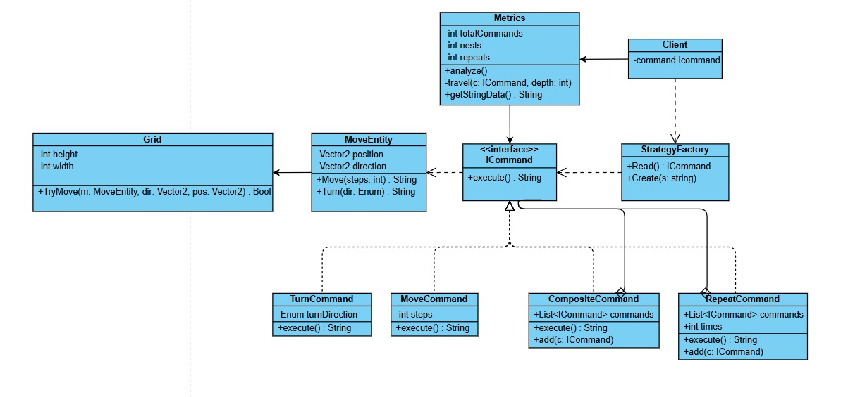
ICommand: We have chosen for an composite design pattern for the commands. This way we can easily add more commands in the future, and we also have a tree structure in which we can build a chain of commands with CompositeCommand being the main command. RepeatCommand can also hold a list of commands, allowing for deep nesting. This way, the commands are separated from other classes and can easily be used as an interface with execute().
StrategyFactory: For reading the input, we have chosen to combine the factory and strategy design patterns. This works by having the factory choose the right strategies, which are currently reading example programs or file input. This way the client can always expect a runnable ICommand, regardless of the chosen input. For the UML we have chosen to exclude the different types of inputs, as these will likely be expanded upon later, and are less important to the core of the application, but the most important is that it returns an ICommand using read().

MoveEntity: This class currently represents the player from the assignment, but can easily be made into a superclass should the project require so later on, from which for example a player would inherit from.
As explained above we have chosen to use the composite, factory and strategy patterns. Using the composite we can easily build a chain of commands as a tree-like structure. Combining factory and strategy allows us to easily implement different types of input, while making sure it always returns an ICommand to the client regardless of the chosen input.
We have made a few of our own assumptions based on the text to build our design:
- There is no grid implementation yet that the MoveEntity (player) has to check for, this will be likely expanded upon though later
- The user chooses input (example/file) and output (path/metrics) through the console, and provides a complete file path when “file” is chosen.
- The syntax for the file input has to be very exact: for example missing indentation will immediately return an error

Part 2
1. Cohesion and Coupling Analysis
Our design is created so classes interact minimally with each other, and functionality is split into appropriate classes/interfaces. This creates high cohesion (each class has their own purpose) and low coupling (the classes know very little about each other).
As stated earlier, this is mainly achieved by splitting the core of the functions: handling the input will always just return a single ICommand which can be used to run or display metrics. This way the client has to know very little about how the factory works, it just expects an ICommand (low coupling).
Classes like MoveEntity, Grid, Metrics and iCommand were designed to especially have high cohesion: the functionality they have only applies to their own class.
- The player can Move() and Turn()
- ICommand has been set up minimally, it only holds data relating to itself and calls methods from MoveEntity without interacting any further.
- The grid currently only checks whether a move is possible and just holds the boundaries (not implemented further yet)
- Metrics traverses an CompositeCommand as a tree structure, but doesn’t interact with it, it only increments its own attributes.
We designed it with future changes in mind as well:
- the composite pattern allows for easy creation of more commands
- the factory/strategy pattern was designed to handle multiple forms of input in the future
- the MoveEntity class was designed so it could turn into a superclass in the future from which different entities could inherit from
We thought about implementing a custom cell class to handle future changes, for example inpassable terrain, but decided that using a Boolean 2d grid for now is easier since it lets us adapt to the kind of future changes we might face instead of guessing what might happen right now. In this case, preparing for an uncertain addition would be more work then just leaving the implementation completely open.

3 likely future changes include:
- Adding more grid functionality: the borders aren’t implemented yet but that was hinted at already to be added in the future, but also having multiple entities on the board or obstacles that the player can’t pass through would be an interesting addition.
  - This could be handled through having the moveEntity becoming a superclass from which the player and an obstacle could inherit. Updating the grid method TryMove() to return whether a move is legal or not, would achieve such new movement for example. This would be implemented with the discussed cell class.
- An interactive GUI with blocks, just like scratch
  - This could be handled through the factory/strategy pattern. Another strategy should be made that returns a single ICommand. The logic for this would be new however, the framework for the ICommand already exists so it would just use compositeCommand.Add() and repeat.Add(). This should make it easy to implement within our current design. New GUI software would have to be implemented within our design though, which would require work.
- Another form of input, like JSON.
  - This would be doable the same way as an interactive GUI, by creating a new strategy. This looks a lot like how files are currently being read though, so this would require very little setup and should be easy to implement.

Something that would be harder to implement would be adding user defined functions instead of simple commands like Move or Turn. This would be in line with making an app for learning visual programming, as functions are crucial to understanding programming, but would be hard to implement as ICommand would have to be adaptable. This would require ICommand having access to all entities and the grid, which required a full rework of the design we currently have.

Part 4 - Work distribution and reflection

After the last projects planning was kind of rough due to illness, we wanted to get a head start on this one and decided to spend at least a werkcollege to work on this in person (since neither of us are participating in the bonus points, this was the easiest way to plan a meetup), in which we hammered out a rough sketch of the UML, and a plan for how to implement this and which future changes we would be prepared for. So then we could both work on different parts of the project at home. We then both did our own parts of the project code, with Storm doing most of the unit tests, after which we decided that since we already had a rough sketch of our UML and basically only needed to formalize it, Kelvin would do that while Storm would finish the report (Work distribution and reflection.)
Retrospectively, we found out on just the last day that we needed to implement unit tests, which was unforeseen and unfortunate as Kelvin didn’t have any time that evening to work on the project, so Storm had to implement them last-minute on his own. Luckily this worked out as he just made it in the nick of time, while at the last moment Kelvin could organize the design document. The physical meetup we had, in which we hammered out most of the plan, was extremely productive and helpful, and all in all communication was smooth.

